THIS MONTH AT TEMPLE BETH AM

111 Avenue B Don Miller, President
Bayonne, NJ 07002 Rabbi Danielle Leshaw
201-858-2020
December 2024

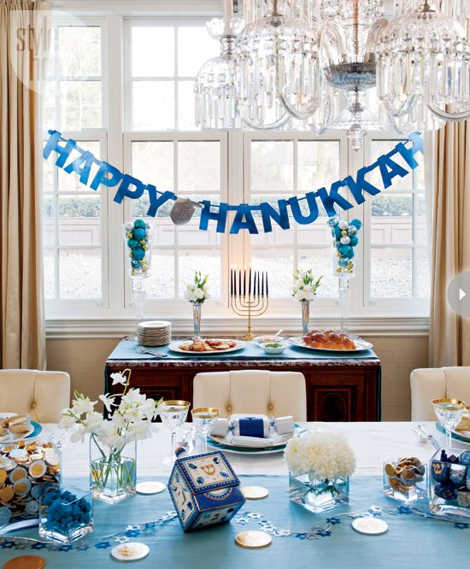

President’s Message

As we approach Hanukkah, we are reminded of the light that shines through the darkness, both in the world around us and in our hearts. Hanukkah, which begins this year on the evening of December 25th, is a time to celebrate the miracles of the past as we gather with loved ones to kindle the menorah, sing songs, share stories, and enjoy the warmth of family and community.
During these winter months, when days are shorter and the nights longer, we may find ourselves turning inward. The winter’s chill offers a perfect opportunity to appreciate the warmth of our synagogue community. Whether through our shared worship services, Torah study, or social events, it is in our togetherness that we find the true light of the season.
I look forward to our working together to continue the renewal of spirit in the months ahead. We have welcomed a new rabbi, Rabbi Danielle Leshaw, and we have begun to have in-person services when we can. Let us continue to support one another as we move into the new year with renewed energy, joy, and commitment to our traditions.
May the lights of Hanukkah bring warmth and peace to your homes, and may the coming months be filled with blessings, health, and happiness. If you have any latkes or sufganiyot you can spare, just give me a call and I’ll be happy to take them off your hands.
Sue and I wish you all a joyous Hanukkah, a happy and a healthy new year, and a wonderful winter season! Please keep Israel, her soldiers, and the hostages in your prayers.

Warmly,
Don

Meet Rabbi Danielle Leshaw

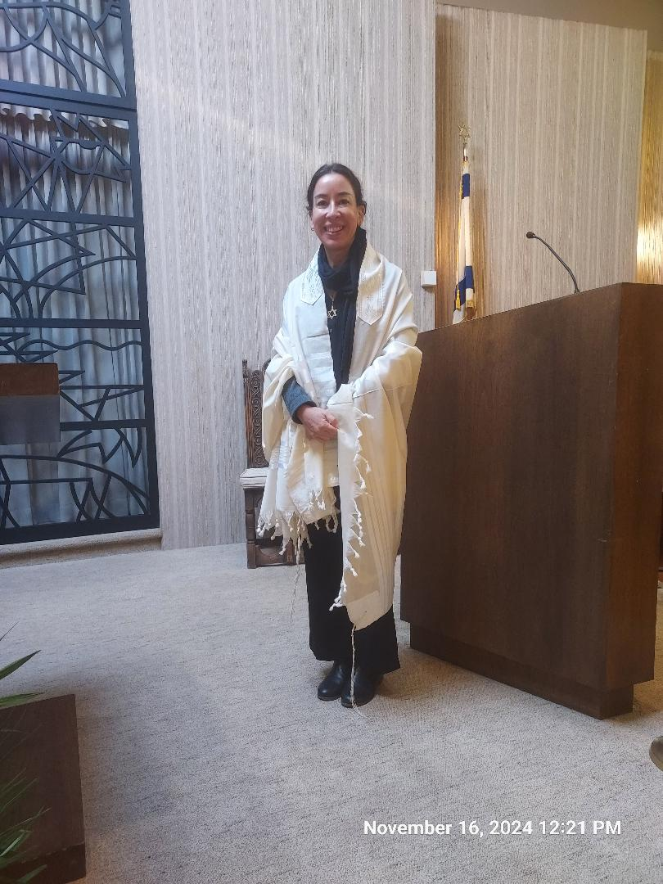

Rabbi’s Message

I hope you’ve had a lovely Thanksgiving weekend, filled with warmth, gratitude, and meaningful connections.

This time of year invites us to reflect on the blessings in our lives, to share our abundance with others, and to embrace moments of togetherness with family and friends. It’s a season that centers on themes of gratitude, community, and giving back—all of which find beautiful parallels in this week’s Torah portion, Vayetzei.

In Vayetzei, Jacob embarks on a transformative journey, fleeing from his brother Esau and encountering God in a dream of a ladder reaching toward heaven. Awed by this divine revelation, Jacob acknowledges God’s presence and vows to dedicate himself to serving the Divine. The gratitude Jacob expresses is active; he commits to returning a portion of his blessings to God, much like Thanksgiving weekend encourages us to turn our appreciation into action—whether through sharing with others, supporting those in need, or creating meaningful moments with loved ones. Jacob’s dream serves as a reminder that thankfulness has the power to bridge the sacred and the everyday, connecting heaven and earth.

As we move from Thanksgiving into the season of Hanukkah, Jacob’s journey also reminds us of the enduring power of hope and light amid darkness. Hanukkah celebrates resilience, miracles, and the rededication of sacred spaces—both physical and spiritual. Just as Jacob found God’s presence in an unexpected place and responded with faith and action, so too does Hanukkah invite us to recognize the light within us and share it with others.

This season encourages us to strengthen family bonds, embrace gratitude, and dedicate ourselves to bringing more light into the world. May the lessons of Vayetzei and the spirit of Hanukkah inspire us to climb the ladder of hope, thankfulness, and connection, illuminating our lives and the lives of others.

I’m very much looking forward to seeing you all again at Beth Am on Shabbat morning, December 14. Until then, see you on zoom and Shabbat Shalom!

Rabbi Danielle

TEMPLE NEWS

All Temple services are still available as required. Call the
Temple Office, if no one is there, leave a message for a call back.

********************************************************

Join us on Saturday December 14th at 10:30 am

when we celebrate the Sabbath and upcoming

holiday of Hanukkah

(In Temple)

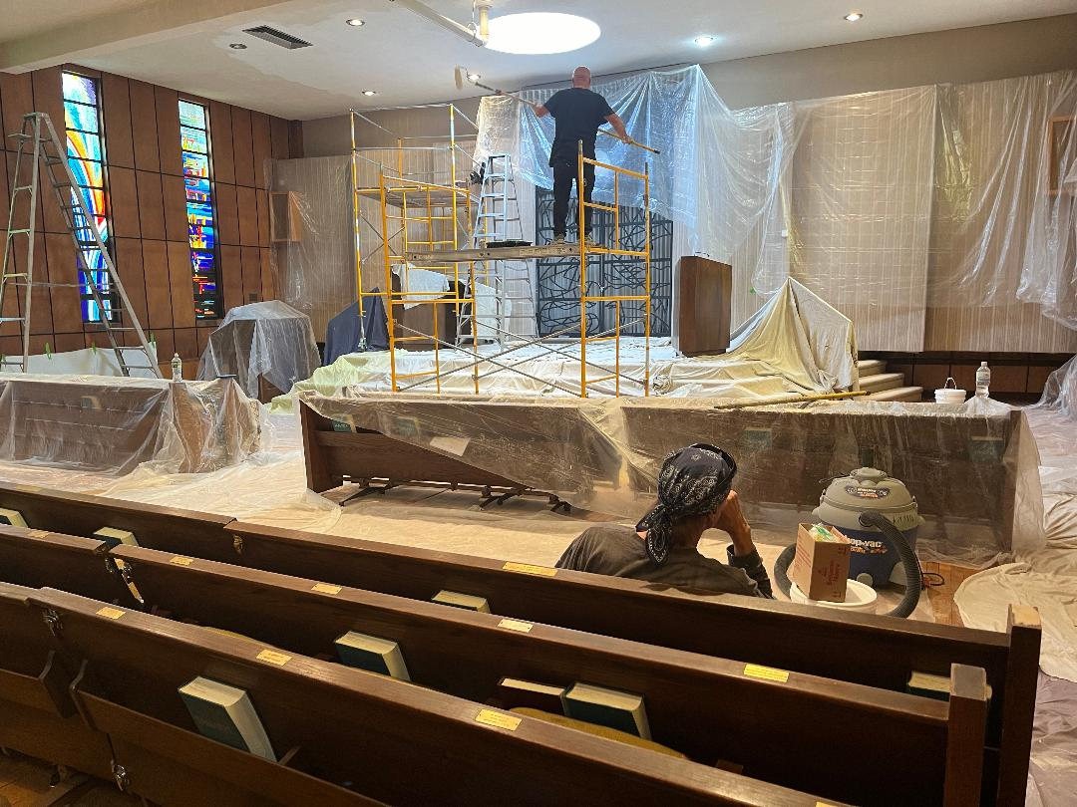

Come see how beautiful the sanctuary looks after being refurbished

The next Indoor service Saturday December 14th – 10:30 am

followed by our get-together Oneg

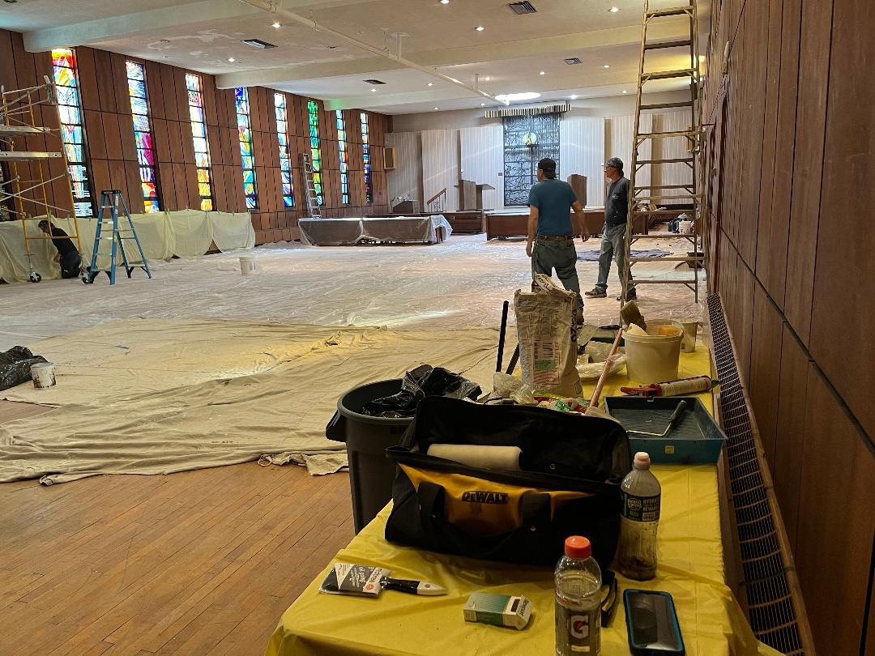

Temple sanctuary in process of being spruced up. Looks great!

Damaged sanctuary floor had to be repaired and refinished. One of the
recent storms damaged the ceiling and the floor but all is finished and
looking great and ready for our next party.
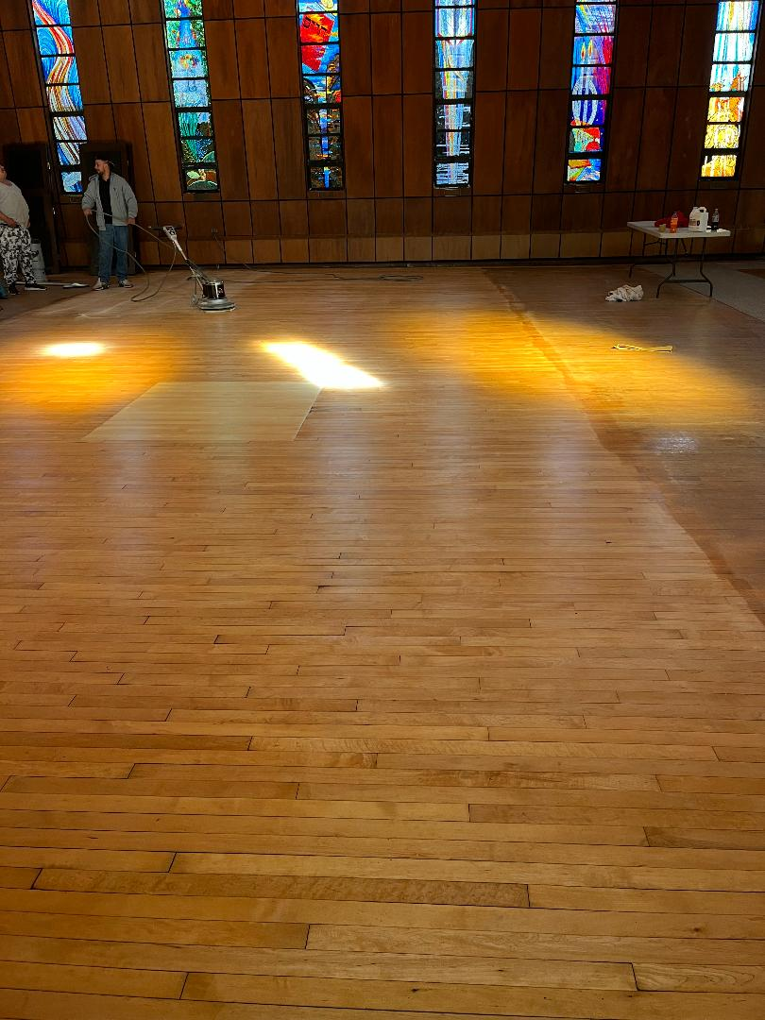
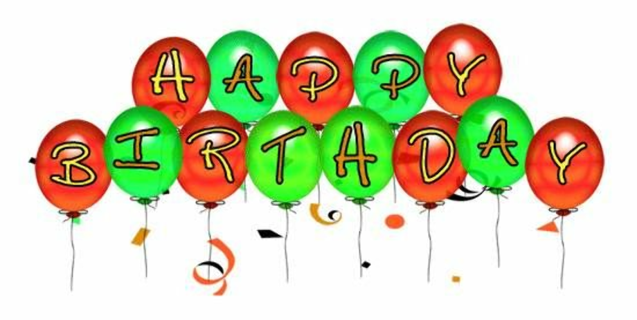

Leonard Rudner December 9

Judah Moon Kawalek December 21

Donald Miller December 29

Floretta Glinsky December 31

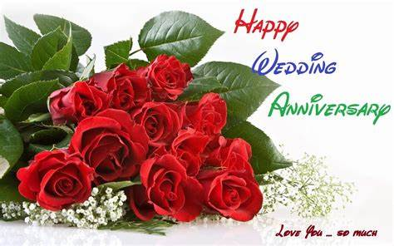

Don & Sue Miller

December 25

TRIBUTES

FROM TO

MUSIC FUND

Joyce Nestle Mrs. Rita Gordon Get Well Wishes
______________________________________________________________________________
Joyce Nestle Mr. John Zaff Get Well Wishes
______________________________________________________________________________

Sue & Don Miller Howard & Renee Feder Wishes for a complete healing
to both of you
______________________________________________________________________________

YAHRZEITS

Eva Visco In Memory of Mother Florence Grossman

Lewis Kerman In Memory of Father Oscar Kerman &
Brother Ira Kerman
______________________________________________________________________

Julian Gott In Memory of Philip Gott
__________________________________________________________________________________

Nancy Zuckerman In Memory of Jack Zuckerman
_____________________________________________________________________

GENEROUS DONATIONS

Lewis Kerman In Memory of Father Oscar Kerman and
Brother Ira Kerman and
In Honor of Good Friends Renee & Albert Bousso
______________________________________________________________________________

James Sanderson Many thanks, James, for your donation
______________________________________________________________________________

SEE YOU ON SATURDAY DECEMBER 14TH

AT SHABBAT SERVICES 10:30 AM

YAHRZEITS – DECEMBER 2024

The Individual Yahrzeits will be read during the upcoming Shabbat Service

Saturday – December 7, 2024

David Lipkowitz (Kislev 1) – Louis Rosen – Mendel Konigsberg – Blanche Friedberg – Alex Guest

Mildred Cozewith – Robert I. Appel – Minnie Rubin Goldfarb – Leo Leichter

Saturday – December 14, 2024

Meyer Chertoff (Kislev 8) – David Cohen (Kislev 13) – Jacob Simon – Henry B. Rosenberg – Esther Katz

Goldie Fishman – Lena Novik – Sarah Rubin Bank – Edward Shapiro, MD – Lena Rosenberg

Daniel Feinberg – Isadore Allen – Albert Weisman

Saturday – December 21, 2024

Claire Frank (Kislev 19) – Benjamin Schwartzman (Kislev 19) – Sadie Klimpl – Bertha Simon

Ida Doroshinsky – Gladys K. Appel – Herman I. Lauton – Hyman Rosenberg – Dora Tuchman

Felix Vogler – Henrietta Greenberg – Anne Fleishman

Saturday – December 28, 2024

Joseph Weinberger (Kislev 24) – Fay Gish (Kislev 24) – Fred “Hepsy” Hirsch ( Kislev 27)

Celia Lieb (Kislev 29) – Sadie Gleich – Gussie Ellis – Joseph I. Kozinn – Anna Birne – David Land

Sarah Schoenfeld – Anna Kur – Eugene Lasky – David Levinson – Norman J. Harris – Oscar Russ

Kate Friedberg

Plaques and Gifts

Yahrzeit Plaques ($250 for members)
Zachor Wall Plaques ($100-$150)
Shabbat Prayer Book Dedications ($50)
High Holy Day Prayer Book Dedications ($25)

Contact the Temple office for details.

Funds and Tributes

The Temple maintains a number of funds supporting various programs at the Temple.
Endowment Fund ($25)
Library Fund ($18)
Rabbi Morris M. Tosk Fund ($10)
Carol Weinberger Flower Fund ($10)
Robert Blum Music Fund ($5)
Rabbi’s Discretionary Fund ($5)

Unless otherwise specified, all tributes will be
$5 and listed under the Music Fund.

For Tribute & Fund donations please call the Temple Office,
201-858-2020 or Email the Temple at templebay111@gmail.com

CHECK US ON THE WEB

Templebethambayonne.org



Temple Beth Am

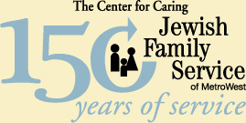

Individual, Family and Group Counseling
Kosher Meals on Wheels
Geriatric Care Management Services
Adoption Services
Information & Referral Service

Most Insurance &
Medicare Accepted

201-604-9991

921 Bergen Ave., Ste. 627, Jersey City, NJ 07306
www.jfs-metronj.org

111 Avenue B
Bayonne, NJ 07002

Phone:

(201) 858-2020

Fax:

(201) 339-1624

Rabbi’s Phone:

(201) 339-1623

E-mail: templebay111@gmail.com

